Lab - Manage Virtual Memory in Windows 7 and Vista

Introduction
In this lab, you will customize virtual memory settings.

Recommended Equipment
- A computer with Windows 7 or Vista installed
- The hard drive must have two or more partitions
Note: At least 2GB of free space is recommended on the second partition.
  - Open System Properties
    - Click Start > right-click Computer > Properties > Advanced system settings.
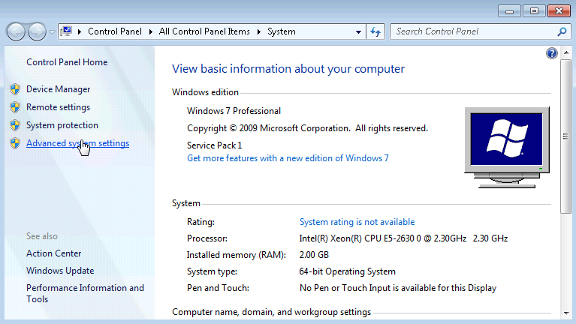
    - The System Properties window opens. Select the Advanced tab and click Settings in the Performance area.
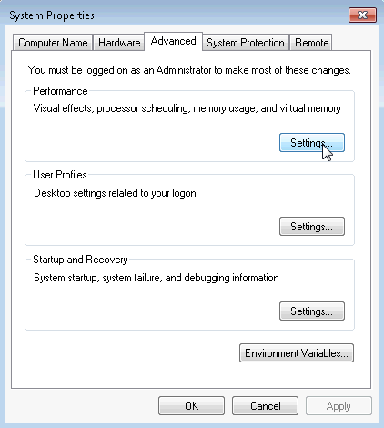
    - The Performance Options window opens. Click the Advanced tab.
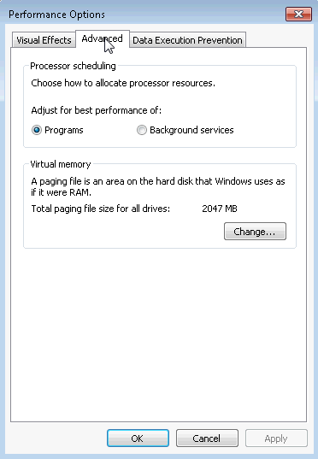
What is the current size of the virtual memory (paging file)?
____________________________________________________________________________________
  - Make virtual memory changes.
    - Click Change in the Virtual memory area to open the Virtual Memory window.
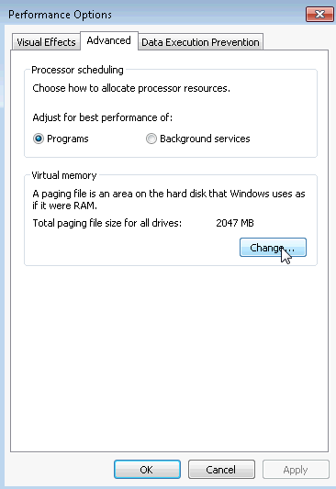
    - Remove the check mark from Automatically manage paging file size for all drives.
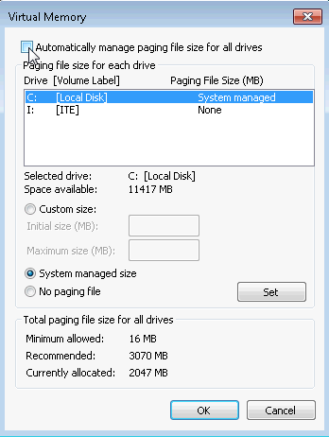
What Drive [Volume Label] contains the paging file?
____________________________________________________________________________________
    - Choose the I: drive. Select the Custom size: radio button.
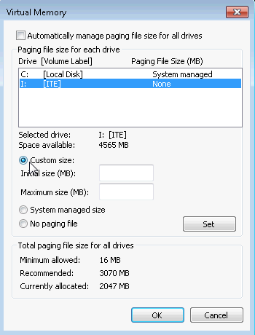
Note: Your drive letter and volume may be different than the example. Replace I: with the drive letter for your second partition on your PC.
What is the recommended paging file size for all drives?
____________________________________________________________________________________
    - Enter a number smaller than the recommended file size in the Initial size (MB): field. Enter a number that is larger than the Initial size but smaller than the recommended file size in the Maximum size (MB): field. Click Set.
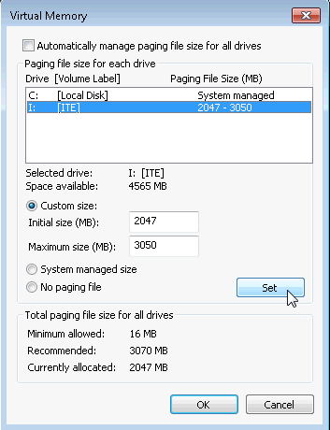
    - Select the C: drive. Select the No paging file radio button, and click Set.
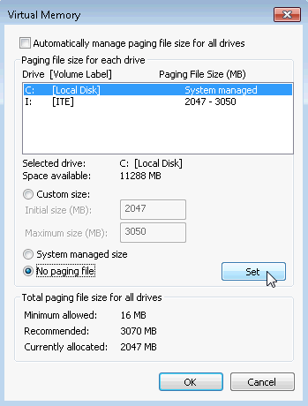
    - The System Properties warning message displays. Click Yes.
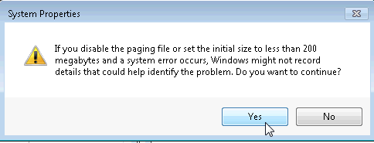
    - Click OK on the Virtual Memory window to accept the new virtual memory settings.
    - Click OK on the Performance Options window to close it.
    - Click OK on the System Properties window to close it.
  - Navigate back to the Virtual Memory window to verify changes.
    - The System Properties window opens. Select the Advanced tab and click Settings in the Performance area.
    - The Performance Options window opens. Select the Advanced tab, and click Change.
    - The Virtual Memory window opens displaying the new paging file information. Verify that your changes have been made.
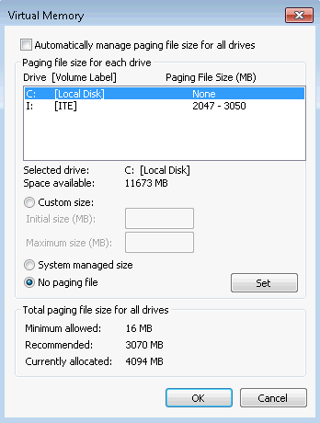
What Drive [Volume Label] contains the paging file?
____________________________________________________________________________________
  - Reset the virtual memory back to the original settings.
    - Select drive C: [Local Disk] > System managed size > Set.
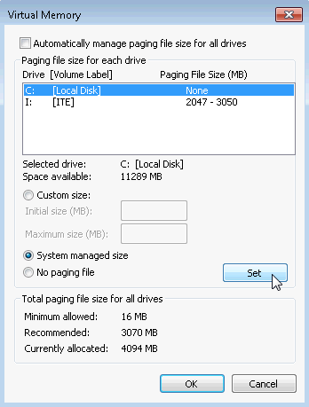
    - Select I: > No paging file > Set.
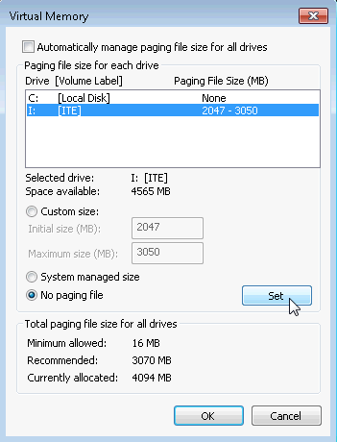
    - Check Automatically manage paging file size for all drives, and click OK.
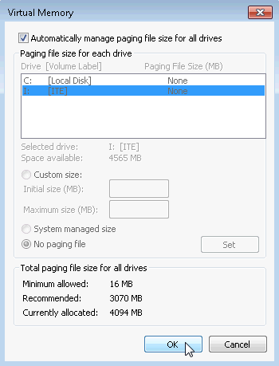
    - The System Properties window opens informing you that a restart is required before changes will take effect. Click OK.
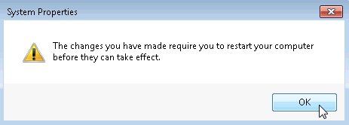
    - Click OK to close the Performance Options window. Click OK to close the System Properties window.
    - The warning message displays: You must restart your computer to apply these changes. Click Restart Now.
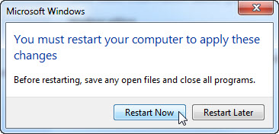

Reflection
Why would you ever change the default virtual memory page file settings in Windows?
_______________________________________________________________________________________
_______________________________________________________________________________________
_______________________________________________________________________________________
_______________________________________________________________________________________
_______________________________________________________________________________________
_______________________________________________________________________________________

